

National College of Ireland

Project Proposal

Automatic Retinopathy Detection Using Digital Image Processing via a Smart Device

November 2020

BSc. (Honours) in Computing

Software Development

2020/2021

Joey Tatú

15015556

joey.tatu@student.ncirl.ie

Contents

Annotations 2

1. Objectives 2

General 2

Checking eye health 2

Features 2

Database 2

Artificial Intelligence 2

2. Background 3

3. Research 3

Diabetic retinopathy 3

Image processing 4

Classification of DR stages: 4

Techniques 4

4. Technical Approach 5

Patient / Medical profiles 6

Health 6

Scanning and checking retina 6

Version control and methodologies 6

5. Special Resources Required 6

6. Project Plan 7

7. Technical Details 8

8. Evaluation 8

Unit Testing 8

Integration testing 9

Scenario 1: Medical professional accessing patient information 9

Performance Testing 9

Response time 9

Users and database 9

References 10

# Annotations

|  |  |
| --- | --- |
| App | Application (e.g. on Android or iPhone) |
| Retinopathy | Damage to the retina of the eye |
| Diabetes | Diabetes mellitus |
| DR | Diabetic retinopathy |
| DME | Diabetic macular edema |
| CNN | Convolution neural networks |
| Intent | A page within an Android app |
| Firebase | Online services such as databases and authenticators provided by Google. |

# Objectives

## General

The objective of this project is to create an app that detects retinopathy. This will be created as an Android application using Android Studio.

## Checking eye health

The user will be able to use the in-built camera on their Android phone to scan their eyes to be able to detect retinopathy and to determine their health. The scan will be completed using artificial intelligence and image processing. It is expected that this app will be provided to medical professionals to assist in their diagnosis of a patient.

## Features

Apart from checking the patient’s retinopathy, the app will be able to record patient’s general Health, for example; blood sugars, blood pressure, etc. The medical professional will be able to monitor the patient’s health and determine if the retinopathy is improving or worsening.

## Database

The database will be implemented via Google Firebase Realtime Database. This is a No-SQL database that is generally used for Android apps.

The main tables in the database will be Patients, Health Information and Retinopathy Results.

The Patients table will contain general information on the patient such as their name, age, and medication they are on. The Health Information table will contain the patient’s Health status such as any illnesses, blood sugars, blood pressure, weight and height. The Retinopathy Results table will contain the results of the retinopathy scan, the damage of the retina, the white to yellow discolouration, as well as the date and time the scan was taken.

## Artificial Intelligence

Artificial intelligence and image processing will be used to scan the patient’s eyes to detect retinopathy. Using convolution neural networks (CNNs) for image processing, issues with the retina will be detected and analysed.

# Background

The idea for this Project began as a vegan health and fitness Android app that would take an image of a person’s eyes and only detect the white to yellow ratio of the sclera. The original idea was founded in late August 2020. As a *de facto*, there are many fitness and health apps available. A health app was proposed for this project, but it was felt that this idea has been exhausted with little success for less popular apps.

The author decided to become vegan in mid-September after they saw that male chicks are destroyed shortly after birth. This is known as “chick culling”. (Wray, 2020) This was a last straw for them, and they decided to become vegan. While personally eliciting information from switching to a vegan diet, there was not that much information was provided. The information that was provide was just recipes and very general information about veganism. The author felt at a loss on how to correctly transition to veganism.  
  
Being vegan, one asks themselves: “Can I eat this?” After trying a few vegan Android apps (described more in Research below), there was no solid information from these apps on whether a product is suitable for vegan. The main answer that was received was “Not sure”. But that was an impasse, as there was no connection to where information could be retrieved to get information on whether the food is Ok for the vegan diet. This project is to redesign vegan, health and fitness apps that are currently available and go above and beyond with improvements. This is how the idea of a vegan health app was discovered.   
  
The idea behind identifying the sclera was founded due to a family member of the author having issues with their gut. This caused the person’s sclera to become a tint of yellow and their skin to become sallow. The author thought that a health app with scanning the sclera would be a beneficial idea.

As the project idea progressed, the innovation for the Project was lacking. Creating a general health and fitness app has been done many times previously. It was decided to change the project slightly and to focus on detecting retinopathy in a patient’s eyes using artificial intelligence and image processing.

# Research

## Diabetic retinopathy

A widespread disease across the globe is diabetes. Diabetes is caused by the body being unable to create insulin. Without treatment, this causes the blood sugars in the body to become high. People who have diabetes for a very long time can get diabetic retinopathy (DR). (Kirange, et al., 2019)

DR is a condition where the blood vessels in the retinas become damaged. This causes the blood vessels to leak which can result in a person becoming visually impaired. All types of diabetes can result in DR with those having the condition for more than two decades being at a higher risk. Signs that a person has DR is shown with irregularities to the retina. Such irregularities are fluffy white spots in the retina known as “cotton wool spots”, small white or yellow tinted build-ups that look waxy or shiny are known as “hard exudates”. Haemorrhaging or microaneurysms can also occur. (Kirange, et al., 2019)  
  
Another issue that can occur with retinopathy is diabetic macular edema (DME). DME is an accumulation of fluid in the macula. The macula is a part of the middle of the retina. (National Eye Insitute, 2020) DME can cause a patient’s vision to become blurred. It can also cause metamorphopsia, which is a vision impairment that causes straight lines, such as those in a grid, to appear round or curved. Other viewing issues can occur such as seeing colours incorrectly and having issues with reading. (Kim, et al., 2019)

## Image processing

### Classification of DR stages:

“Stage I: No diabetic retinopathy”: A retina that has no DR.

“Stage II: Mild non-proliferative diabetic retinopathy”: A retina that has microaneurysms only and on other signs of DR.

“Stage III: Moderate non-proliferative diabetic retinopathy”: A retina that can have either microaneurysms, minor haemorrhaging, hard exudates or cotton wool spots.

“Stage IV: Severe non-proliferative diabetic retinopathy”: A retina that can have a lot of haemorrhaging, significant constriction and dilation of venules (small blood vessels in the retina), abnormal branching of venules or existing venules dilating.

“Stage V: Proliferative diabetic retinopathy”: Natural formation of blood vessels and bleeding into the fluid in the macula.  
  
(Wang, et al., 2019)

### Techniques

A group of neural networks is known as “convolution neural networks (CNNs)”. CNNs are established to be successful in image processing and cataloguing. Some of the enhancements with CNNs are that the blurriness in the image can be detected as well as making the image clearer and being able to detect edges.

Three of the most-modern CNN designs are AlexNet, VGG16 and InceptionNet (now Google’s LeNet), specifically for DR stage categorising.

AlexNet is a model by Alex Krizhevsky, Ilya Sutskever and Geoffrey Hinton, with Hinton being Krizhevsky’s Ph.D. consultant. From older CNNs, AlexNet improved the error rate speed as older CNNs have significantly increased error rates in comparison. It can set the result of non-visible neurons to nil, with a 50/50 probability.   
  
VGG16 is an advanced version of AlexNet. Its advantage is how the image is processed adding more viewable layers and filters for better clarity.

LeNet advances AlexNet and VGG16 even further with a reduced error rate and adding more viewable layers and filters.

(Wang, et al., 2019) (Rosebrock, 2018)

# Technical Approach

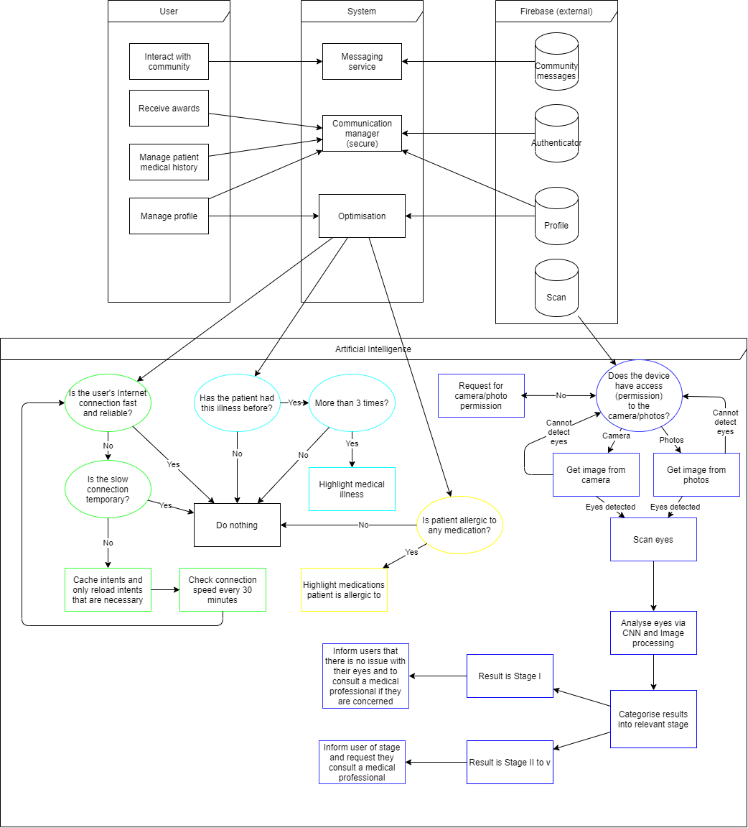(Please see included file TechnicalApproach.png for clarity)

These are the main aspects of the app:

## Patient / Medical profiles

The patients table will be the account information on the app. No actual names will be used. Instead either the likes of a patient’s doctor/hospital number will be used instead.   
  
The medical profile will contain a staff number and password for the medical professional to log in and use the app.

Patient information and profiles will be stored in Firebase Realtime Database and will be authenticated using Firebase Authentication.  
  
Illness querying

The image of a patient’s eye will be uploaded to the Firebase Storage with identifying illnesses (such as haemorrhages, fluid on the macula, etc.). A list of identified illnesses will also be displayed. The medical professional can either tap on the issue on the image or tap on the item in the list to gain more information on the illness detected

## Health

Another part of the app will consider the patient’s health and fitness. This will contain the user’s medical history and any previously detected illness of the retina.

The patient’s medical history will be stored in a NoSQL database online using Firebase Realtime Database.

Scanning and checking retina  
The medical professional or patient can take a photo or upload an image of the eye. The flashlight on the phone will be used to obtain a clearer image. The image will be checked via a CNN and then uploaded into Firebase Storage.

## Version control and methodologies

Version control will be handed using a GitHub repository and will be synced using Git Bash. The version control will be located online at <https://github.com/JoeyTatu/Software_Project_2020_21>.  
  
A mix of Kanban and Scrum will be used for the methodologies.

# Special Resources Required

This Project will be completed in Android Studio using Kotlin coding. Implementation of external code required will be implemented in Android Studio. An example of this is using Picasso for simplifying the process of inserting images into intents and sections of the app.

# Project Plan

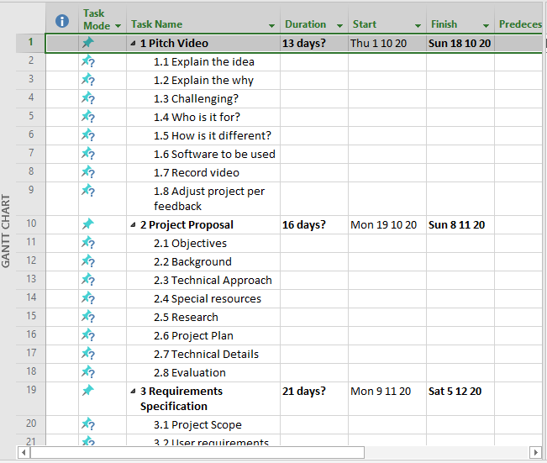

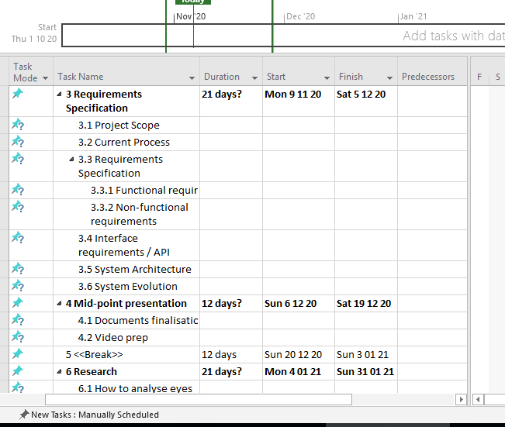

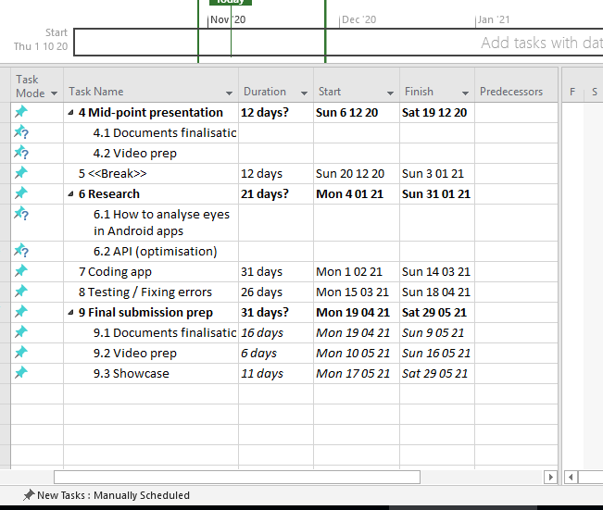

# Technical Details

The Project will be developed in Android, using the coding language Kotlin. The database and user authentication will be handled by Firebase. Firebase Realtime Database is a NoSQL database. Some of the libraries to be implemented will be Google Play Services for adverts and location services, Picasso to assist in inserting images more easily and Circle Image View to create rounded corners on buttons, images and the like.

# Evaluation

A Testing Report will be generated after a section is completed to identify and correct errors.

Some examples of Unit Testing, Integration Testing and Performance Testing include:

## Unit Testing

Assumption: The user has not opened the app before.  
  
Scenario 1: Create Patient profile

* Can the user successfully connect to the database?
* Does the user have internet access?
  + If the user has not got internet access, the test fails.
* Is the data securely sent and retrieved from the database?
  + An example patient information will be created
  + Before sending to the database, an external programme will copy and try to read the data.
  + If data can be read, the test fails.
  + For a successful test, the data should not be viewable by any other program or person, except the database where it’s being inserted or retrieved from.
* Can the medical professional successfully add a patient to the database?
  + The test profile mentioned above will be retrieved and displayed in an intent on the app for testing purposes.
  + A call to the database requesting the profile information will be called
  + If the correct profile information is displayed, the test passes.

## Integration testing

Assumption: The patient information has previously been created.

### Scenario 1: Medical professional accessing patient information

* Integration between a medical professional (test user) and patient information (test patient).
  + The test user inserts recent history into the test patient.
  + The app creates graphs to show how the patient has improved or worsened.
  + The updated test patient information is sent to the database.
  + The updated test patient information is retrieved from the database and put into the test intent
  + If the correct test patient information is displayed with the patient ID, the test passes.

## Performance Testing

Performance testing will be completed using JUnit.

The following will be tested:

### Response time

* The response time must be less than 4 secs with 500 users accessing the database at the same time.
* Check the response time of the app/database when a user’s Internet connection is slow or limited.
* Check response time when the load condition is low, medium and heavy.

### Users and database

* Check what the maximum number of users accessing the app and database before it becomes unresponsive.
* With 500 records being sent and received to the database at one time, check the execution time. The limit would be 10 seconds.

(Tatú, 2019)

# References

Burggraf, C., 2020. *Is It Vegan?.* [Online]   
Available at: https://play.google.com/store/apps/details?id=net.isitvegan.androidfree  
[Accessed 5 November 2020].

HappyCow, 2020. *Find Vegan Restaurants & Vegetarian Food- HappyCow.* [Online]   
Available at: https://play.google.com/store/apps/details?id=com.hcceg.veg.compassionfree  
[Accessed 5 November 2020].

Higgins, J. P., 2016. *Smartphone Applications for Patients’ Health,* Tucson: The American Journal of Medicine.

Kim, E. J. et al., 2019. Treatment of Diabetic Macular Edema. *Current Diabetes Reports,* 68(2019), pp. 1-10.

Kirange, D. K. et al., 2019. Diabetic Retinopathy Detection and Grading Using Machine Learning. *International Journal of Advanced Trends in Computer Science and Engineering,* 8(6), pp. 3570-3576.

Leap Fitness Group, 2020. *Home Workout - No Equipment.* [Online]   
Available at: https://play.google.com/store/apps/details?id=homeworkout.homeworkouts.noequipment  
[Accessed 5 November 2020].

National Eye Insitute, 2020. *Macular Edema.* [Online]   
Available at: https://www.nei.nih.gov/learn-about-eye-health/eye-conditions-and-diseases/macular-edema#:~:text=Macular%20edema%20is%20the%20build,and%20thicken%2C%20which%20distorts%20vision.  
[Accessed 18 November 2020].

Oyibo, K., Ifebude, B., Adaji, I. & Vassileva, J., 2019. Investigation of the Perceived Persuasive Features. *4th International Workshop on Personalizng Persuasive Technologies.*

Rosebrock, A., 2018. *LeNet – Convolutional Neural Network in Python.* [Online]   
Available at: https://www.pyimagesearch.com/2016/08/01/lenet-convolutional-neural-network-in-python/  
[Accessed 18 November 2020].

Tatú, J., 2019. *Body Branding Bookings (3B) - Project Proposal,* Dublin: National College of Ireland.

Wang, X., Lu, Y., Wang, Y. & Chen, W.-B., 2019. *Diabetic Retinopathy Stage Classification using Convolutional Neural Networks,* Virginia: Virginia State University.

Wray, M., 2020. *Germany, France push to end male chick ‘shredding’ in European Union.* [Online]   
Available at: https://globalnews.ca/news/6420754/male-chick-culling/  
[Accessed 2 November 2020].